DMAF5 bios update
Bios download link:
https://www.mediafire.com/file/ksg1q2kpf46c086/AF5_BIOS%25281%2529.rar/file

Bios update log: supports the upgrade of window11.

NOTE：
In order to prevent abnormal shutdown, it is recommended to disconnect the network.
During the update, please don't cut off the power abnormally, and don't interrupt the update process.
1. Unzip the file in the folder and put it on the desktop, as shown below
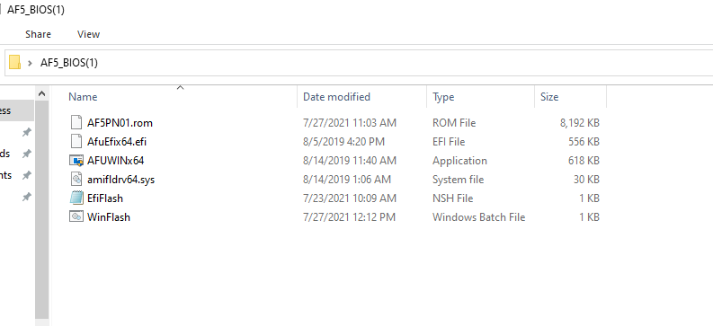

2. In the file option, open windows powershell with administrator privileges
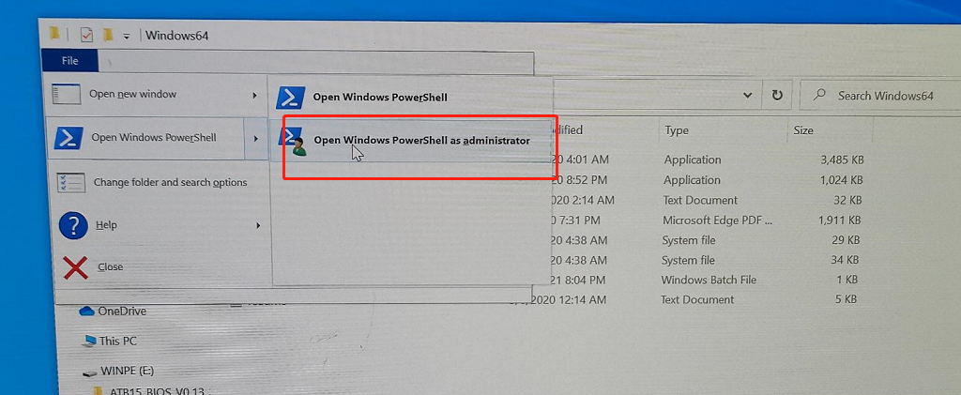

3 Enter on the command line: .\WinFlash.bat
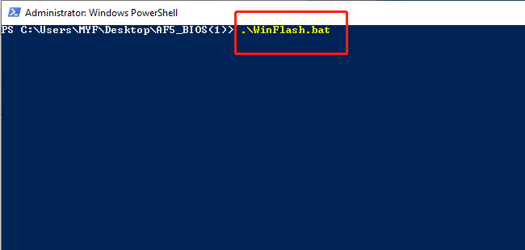

4. The script will automatically update the bios.
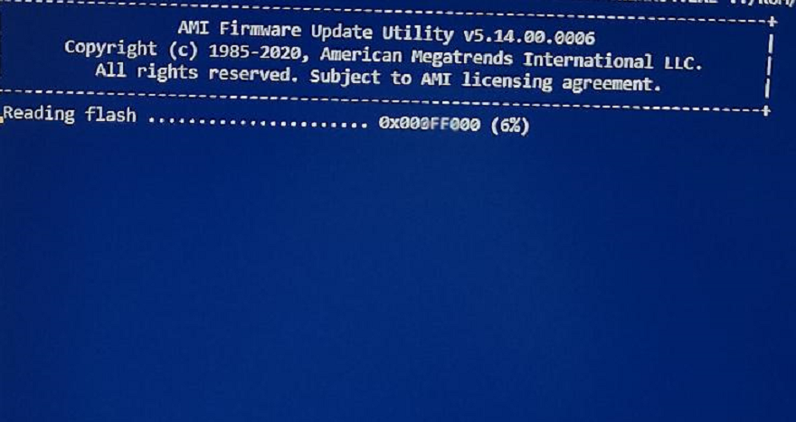

5. After the update is complete, it will automatically restart.

