Bios update on shell
Before updating, please check your bios version. If your bios version is ATB15013, 6/29/2021, you do not need to update.
Bios file（Double-click to get the BIOS file.）:
Bios update log: updated 2G video memory, and supports the upgrade of window11.
NOTE：
During the update, please don't cut off the power abnormally, and don't interrupt the update process.

1.Format the USB flash disk, format : FAT32 , name: WINPE .
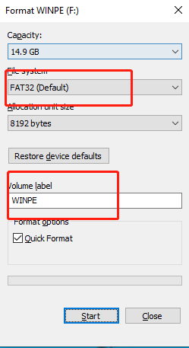

2.Unzip the downloaded ‘X400X300 013 bios’ file to the USB flash drive.
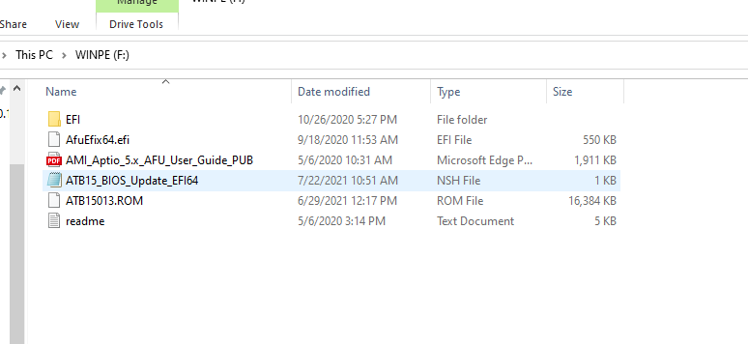

3. Insert the USB flash drive into the PC, After booting, Press F7 repeatedly, select “UEFI: XXXXXX”, ENTER.
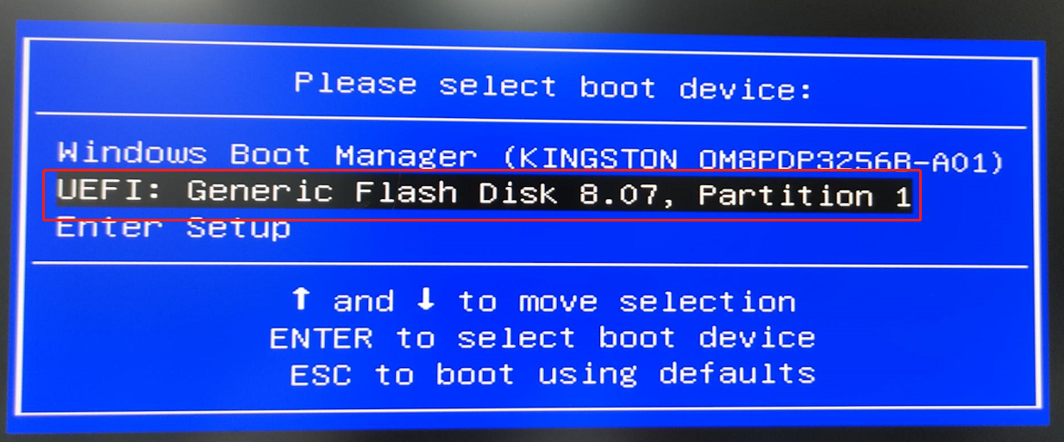

4. Update in four steps
(1) fs*: :Enter the command to find the USB flash disk: enter " fs0: " Enter, then enter "dir" to enter, Check if these files are in your USB flash drive, if not, fs1: , fs2: , fs3: ......Try again
Since my X400 only has one M.2 SSD, the location of the U disk is fs3:
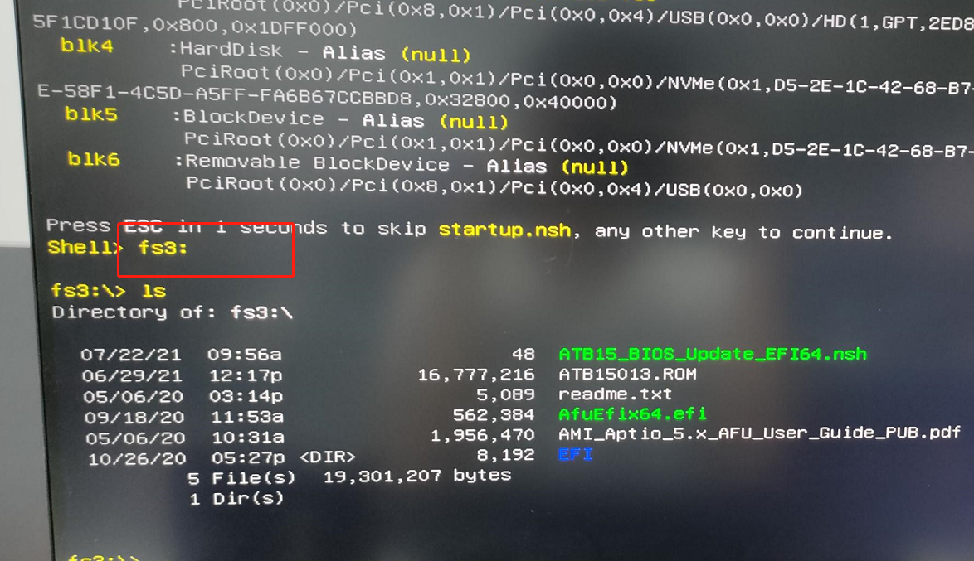
(2) ls : Specify the drive, directory, and/or file to be listed.
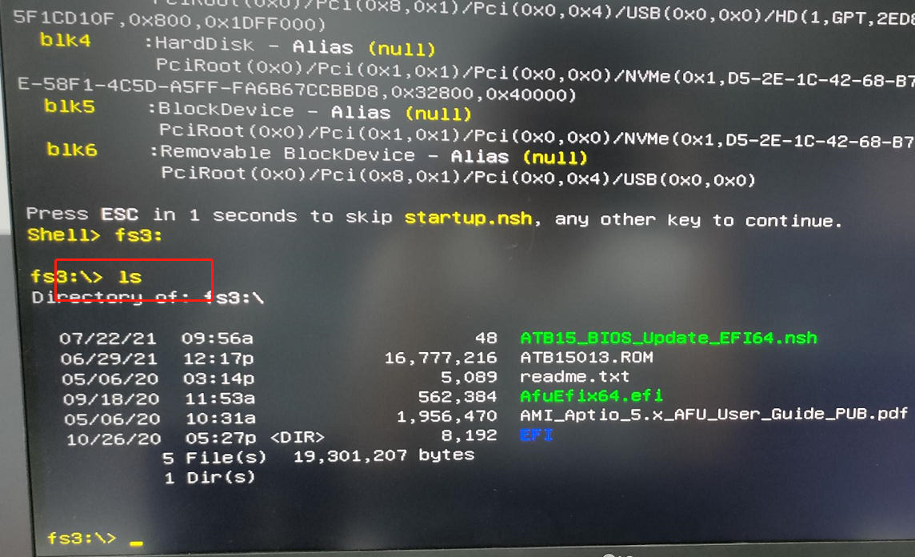

(3)Type ATB15_BIOS_Update_EFI64 : List text content
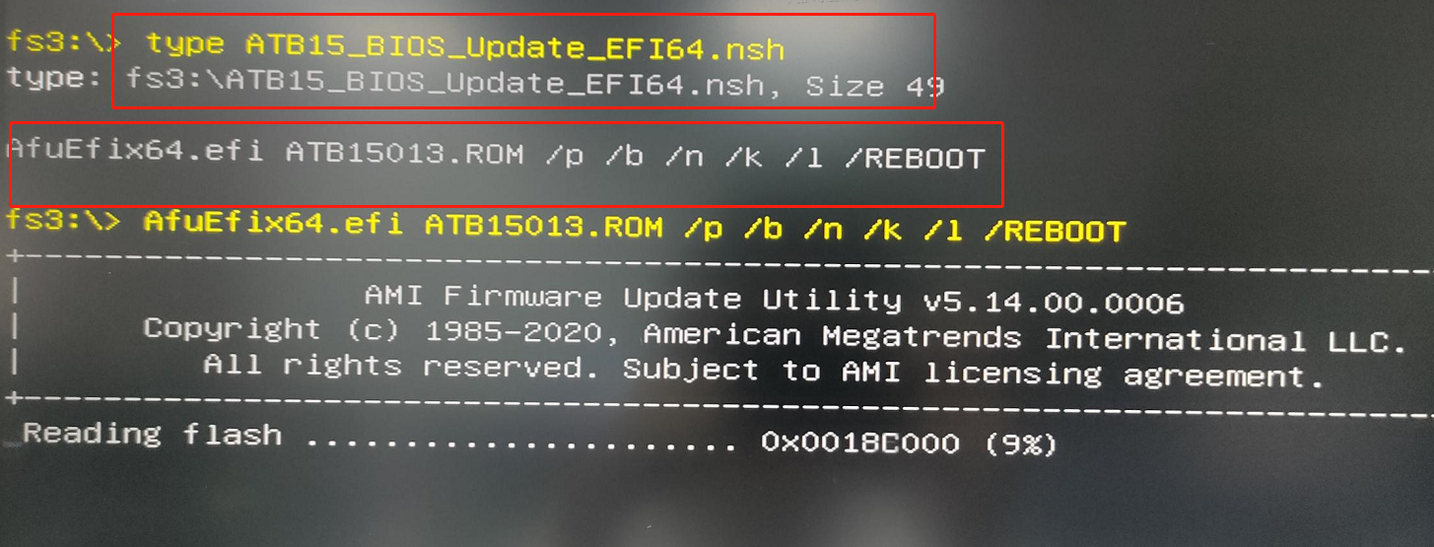
(4) AfuEfix64.efi ATB15013.ROM /p /b /n /k /l /REBOOT : Use ATB15013.ROM to start the update.
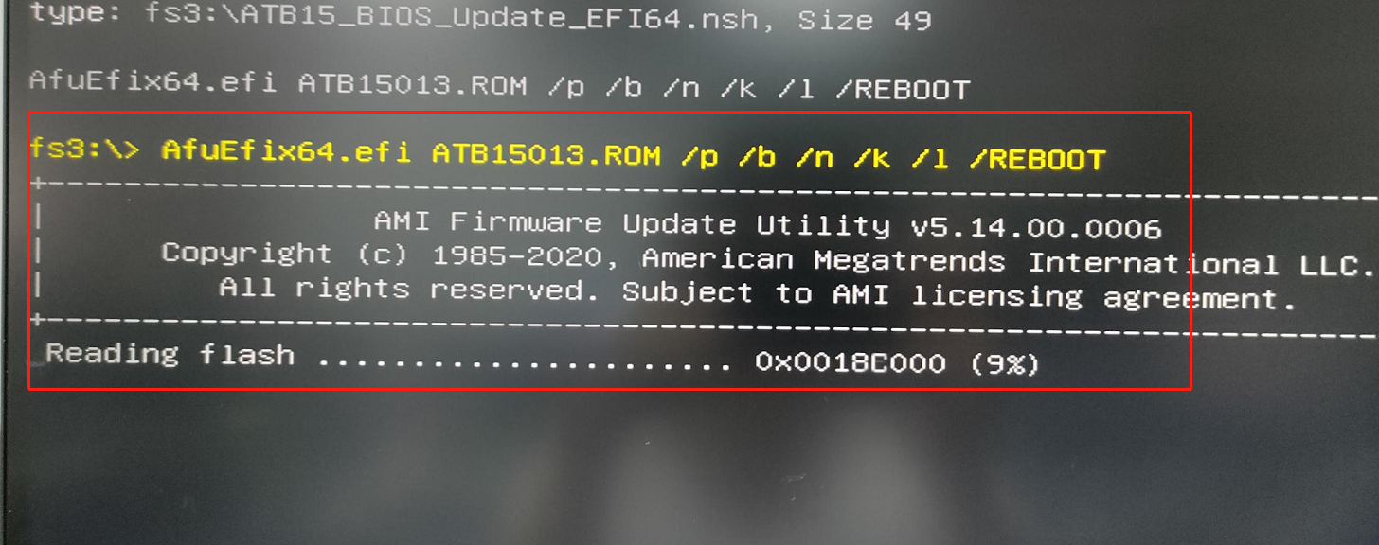

5. After the update is complete, X400 will automatically restart, please be patient.

