Bios update on shell
Please check your bios version before updating. If your bios version date is 08/11/2021, there is no need to update.
Bios download link:
https://www.mediafire.com/file/iqu574lta54aqdn/HM50HM80HM90_bios_.rar/file

NOTE：
During the update, please don't cut off the power abnormally, and don't interrupt the update process.

1.Format the USB flash disk, format : FAT32 , name: WINPE .
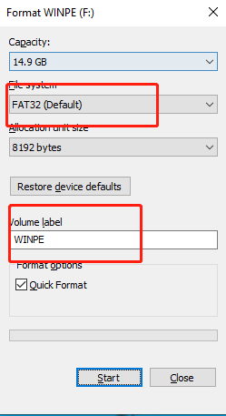

2.Unzip the downloaded ‘HM50HM80HM90 bios’ file to the USB flash drive.
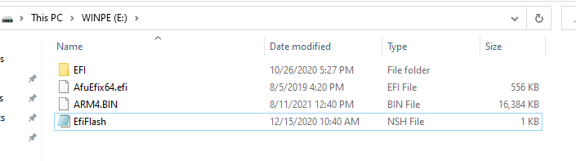

3. Insert the USB flash drive into the PC, After booting, Press F7 repeatedly, select “UEFI: XXXXXX”, ENTER.
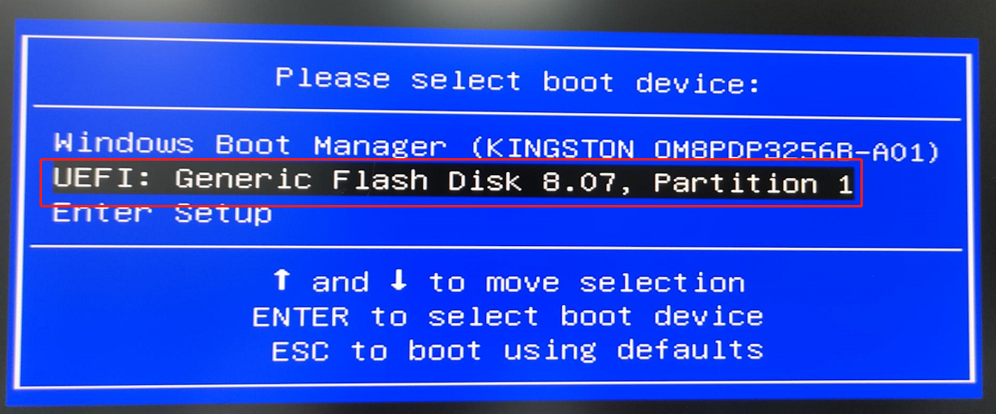

4. Update in four steps
(1) fs*: :Enter the command to find the USB flash disk: enter " fs0: " Enter, then enter "dir" to enter, Check if these files are in your USB flash drive, if not, fs1: , fs2: , fs3: ......Try again
Due to the order of the file system, the location of my USB flash drive is at fs1: 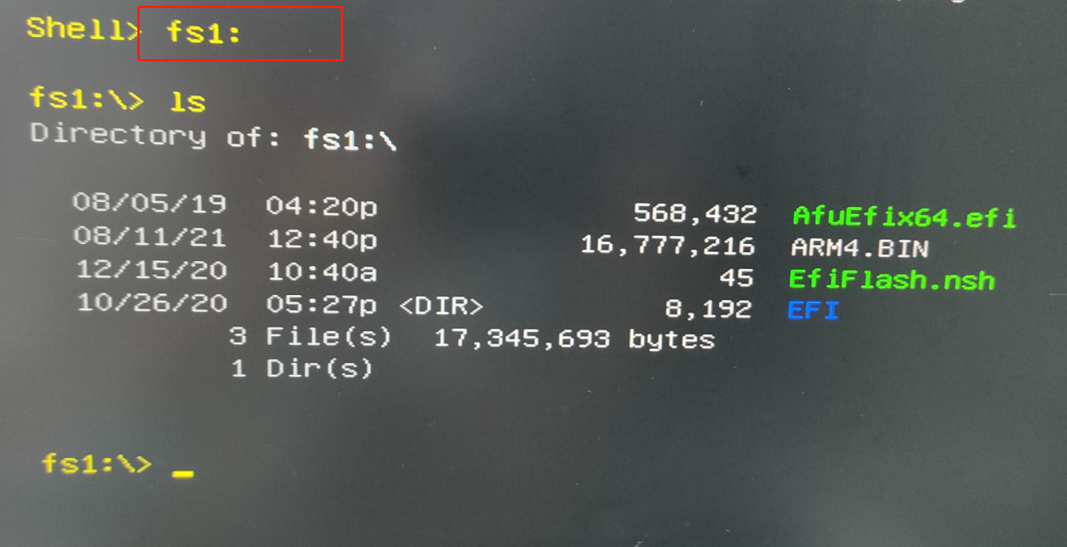
(2) ls : Specify the drive, directory, or file to be listed.
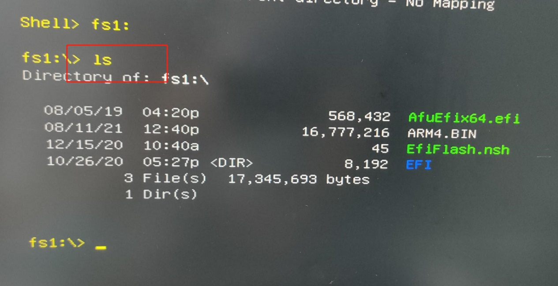

(3)type EfiFlash.nsh : List text content
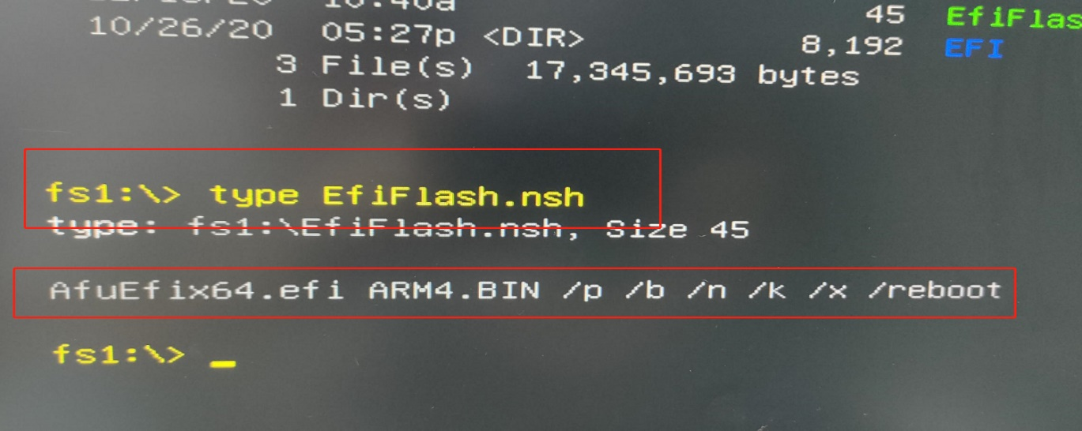
(4) AfuEfix64.efi ARM4.BIN /p /b /n /k /x /reboot : Use ARM4.BIN to start the update.
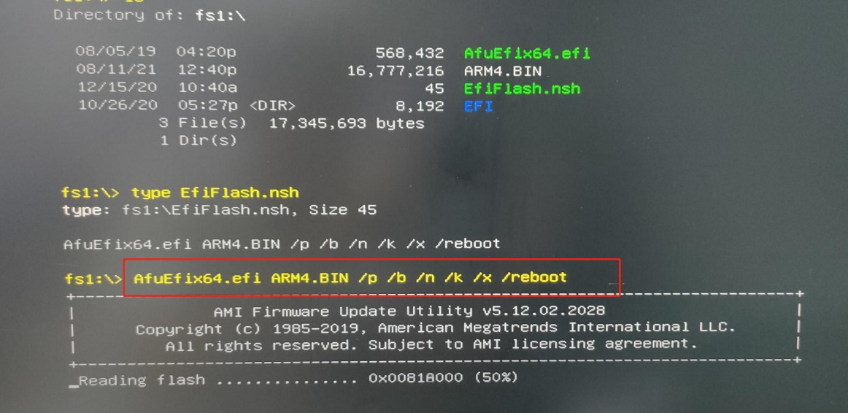

5. After the update is complete, HM80 will automatically restart, please be patient.

