Bios update on shell
Bios download link:
https://www.mediafire.com/file/tfxc9t37zd6chkh/UM700_bios_update_on_shell%25EF%25BC%2588support_windows_11%25EF%25BC%2589.zip/file

Bios update log: supports the upgrade of window11.
NOTE：
During the update, please don't cut off the power abnormally, and don't interrupt the update process.

1.Format the USB flash disk, format : FAT32 , name: WINPE .
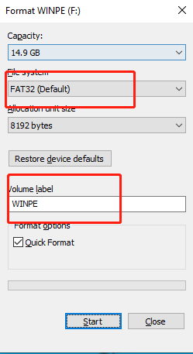

2.Unzip the downloaded ‘UM700 bios update on shell（support windows 11）’ file to the USB flash drive.
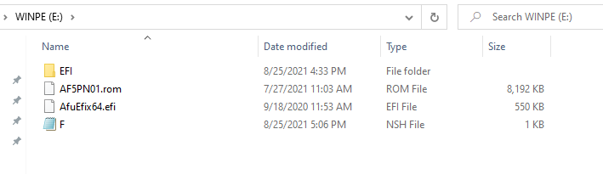

3. Insert the USB flash drive into the PC, After booting, Press F7 repeatedly, select “UEFI: XXXXXX”, ENTER.
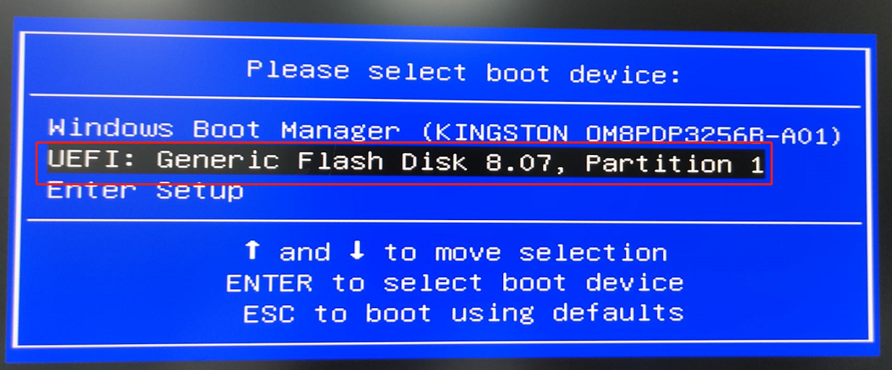

4. Update in four steps
(1) According to EFI identification, the USB flash drive is in the fs1: position. You need to enter fs1: after the shell to access the USB flash drive.
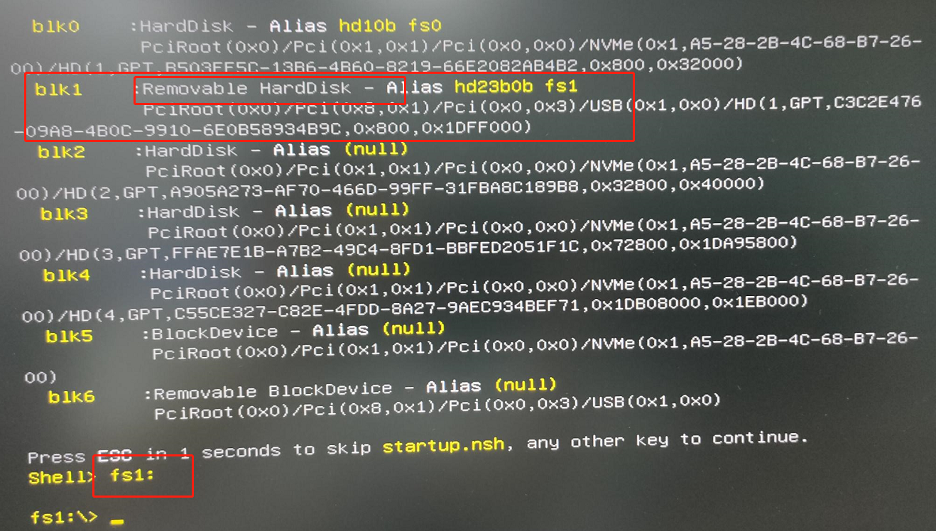
(2) ls : Specify the drive, directory, and file to be listed.
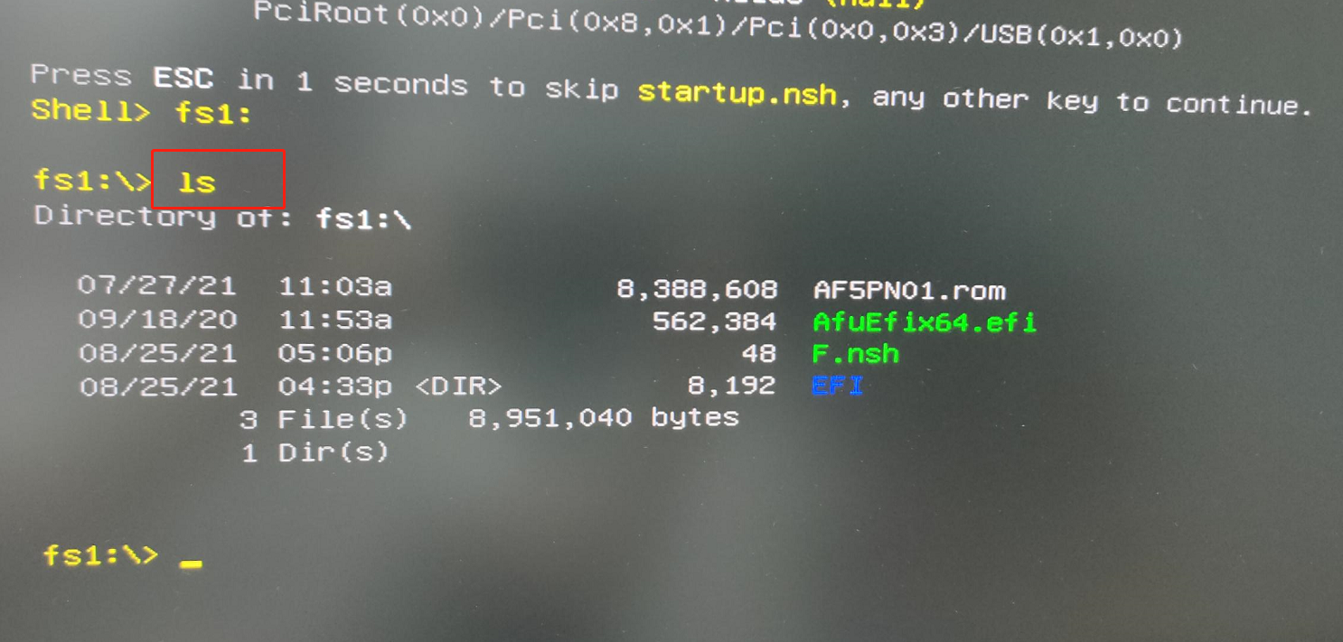

(3)Type F.nsh : List text content
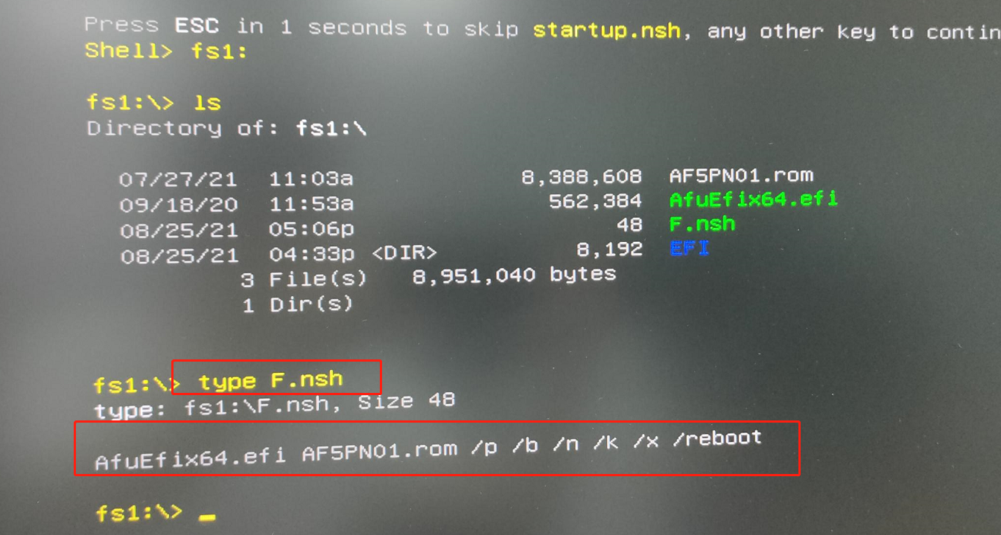
(4) AfuEfix64.efi AF5PN01.rom /p /b /n /k /x /reboot : Use AF5PN01.rom to start the update.
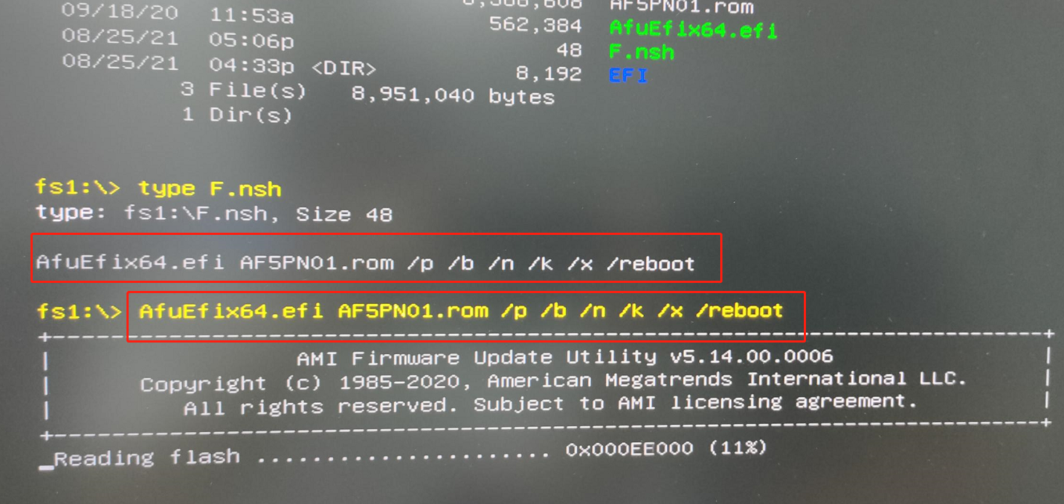

5. After the update is complete, UM700 will automatically restart, please be patient.

