Bios update on shell
Click to download the Bios file：
https://www.mediafire.com/file/1zxqbt01ad5qqd2/X300X400_v016.zip/file
Main change log: Modified the bug of version 015 bios that you need to press F3 to modify the options to take effect.
Warning：During the update, please don't cut off the power, and don't interrupt the update process.
1.Format the USB flash disk, format : FAT32 , name: WINPE .
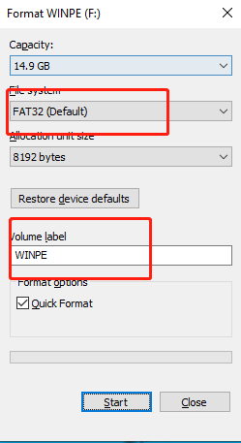
2.Unzip the downloaded ‘X300X400_v016’ file to the USB flash drive.
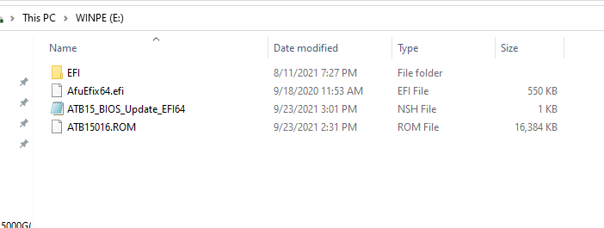

3. Insert the USB flash drive into the PC. After booting, Press F7 repeatedly. Select “UEFI: XXXXXX” and ENTER.
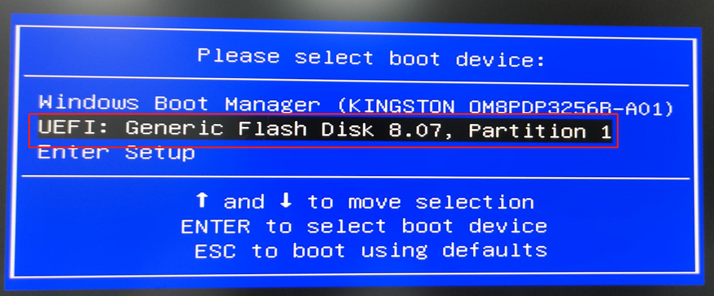

4. Update steps
(1) According to EFI identification, the USB flash drive is in the fs3: position. You need to enter fs3: after the shell to access the USB flash drive.
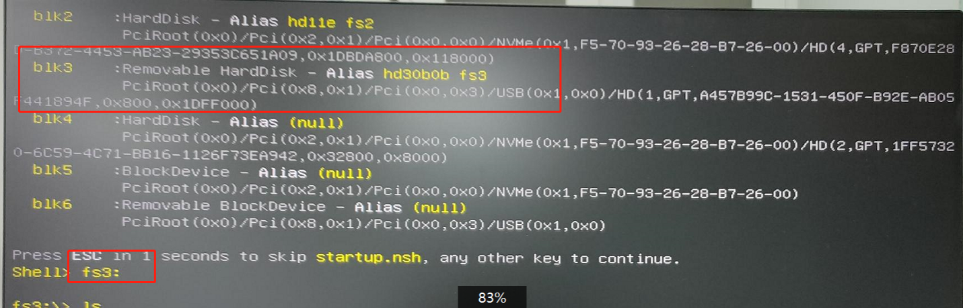
(2) ls : Specify the drive, directory, and file to be listed.
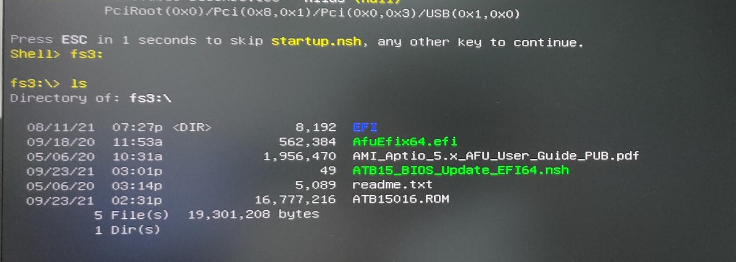
(3)Type ATB15_BIOS_Update_EFI64.nsh : List text content
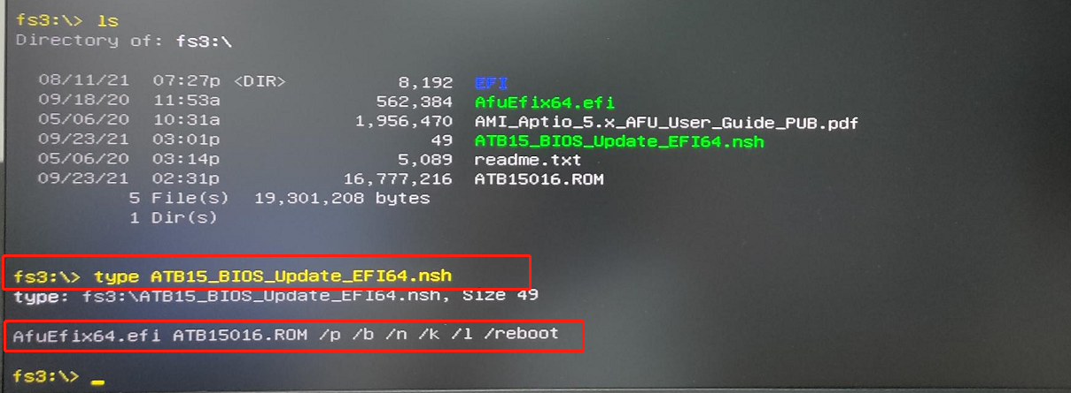
4) AfuEfix64.efi ATB15016.ROM /p /b /n /k /l /reboot : Use ATB15016.ROM to start the update.
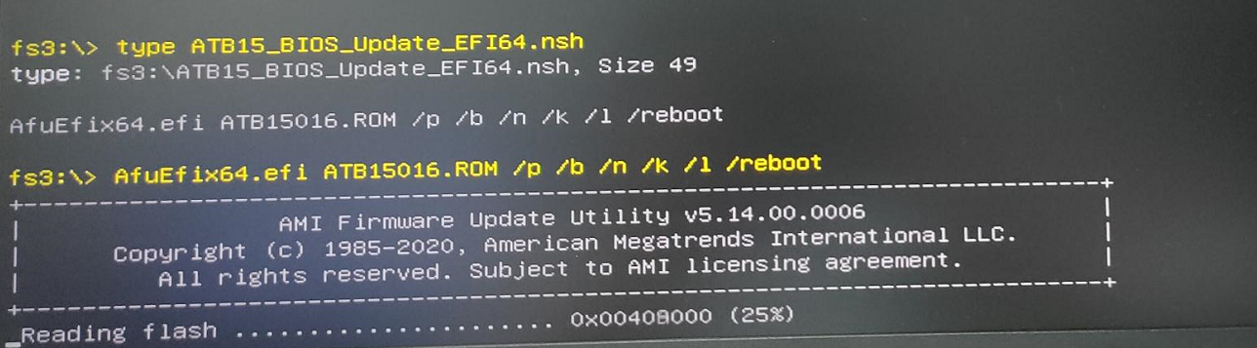

5) If your previous bios version is version 014 or version 015, you can skip this step. If your bios version is before version 014, the following step will appear and you need to press E to confirm.
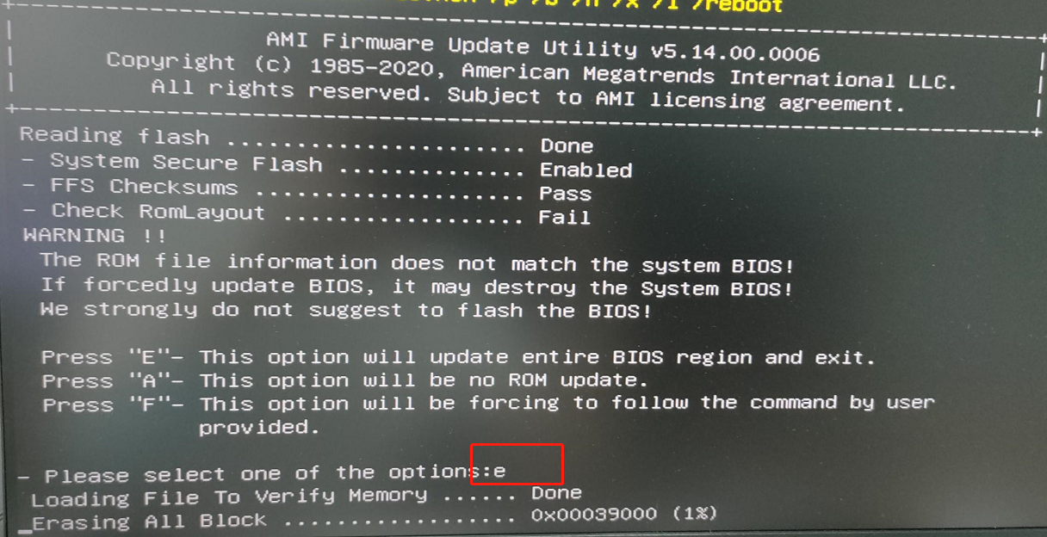
5. After the update is complete, X400 will automatically restart, please be patient…

